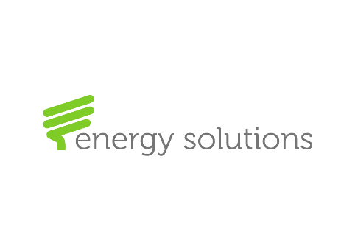Company Profile

Company: Energy Solutions Commercial Establishment

Date of Establishment: 2009

Aim:
In 2009, Energy Solutions was established with the aim at bringing environment friendly technologies that works on reducing energy consumption. In 2012, Energy Solutions established regional manufacturing facilities for Cable plugs, Cables, inserts and terminals. In 2013, Energy Solution started its Biomedical department which works on maintenance of health care facilities as well as representing several reputable international biomedical companies in Kuwait.

Our Partners:
Energy Solutions proudly represents several Reputable international companies listed by department
Biomedical department:
- Diplomat company, Slovakia
- Fona, Italy
- Genoray, Korea
- Manfredi, Italy
- Eurocom, Italy
- Silfradent, Italy
- SGS dental implants, Hungry
- Eurocem, Italy

Electrical and Construction Department:
- Planet Supra, Japan
- Prime Lights, Taiwan
- Regulus, Canada
- Trendy Tiles, UK
- Obras International, Dubai
- Parklex, Spain

Structure:

